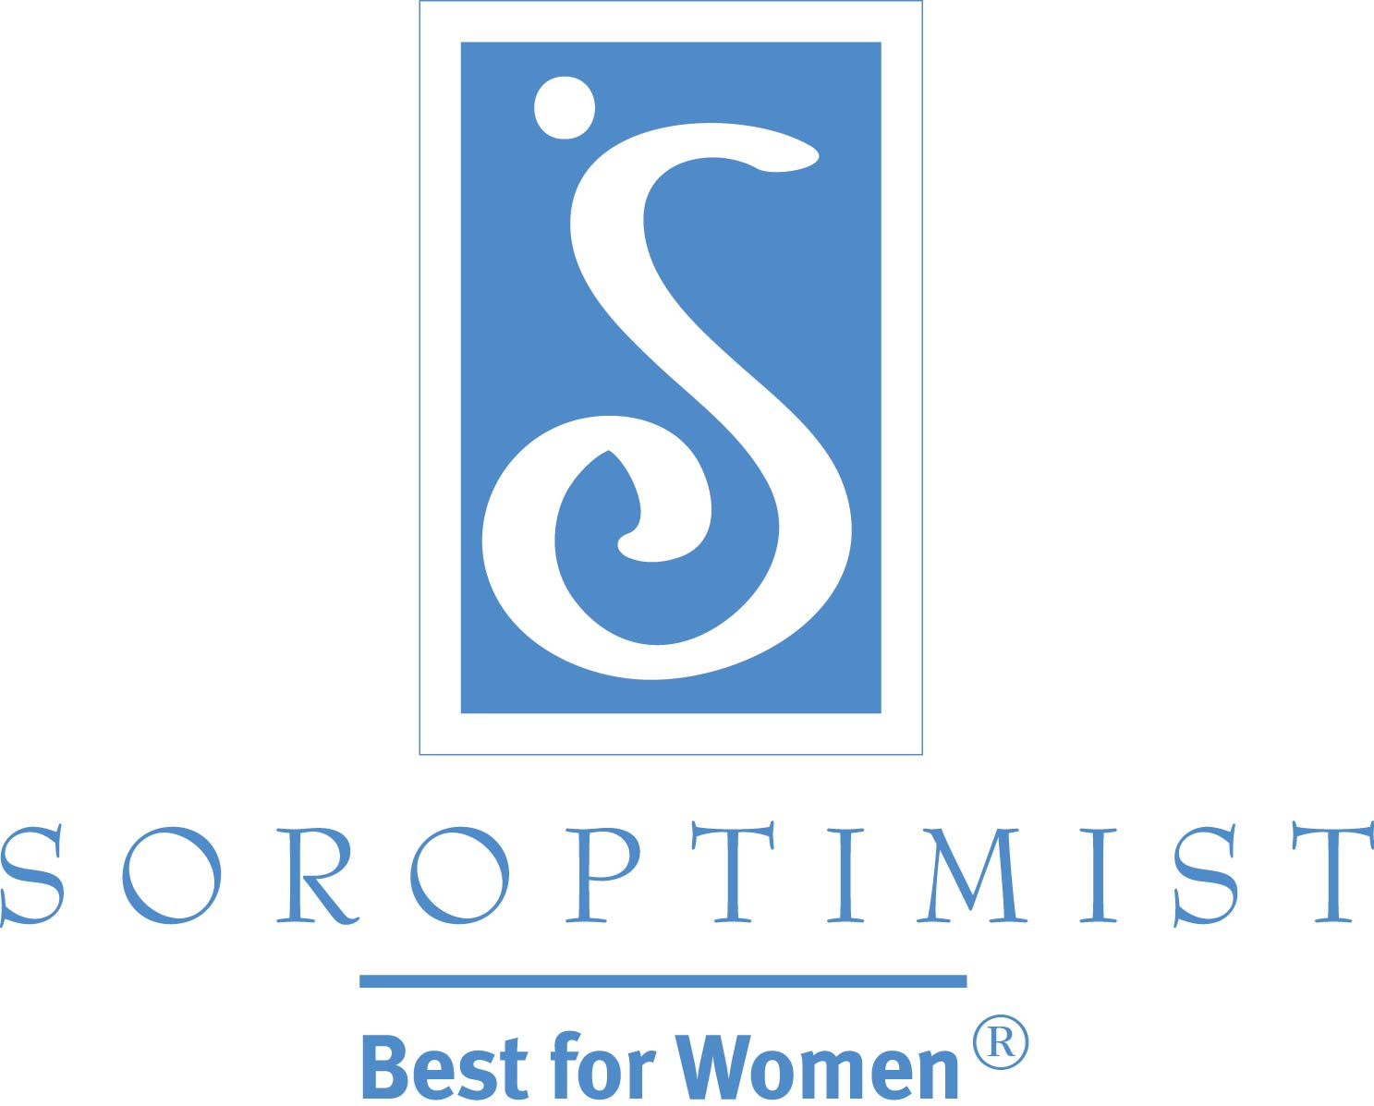
Improving the lives of women and girls
through programs leading to social
and economic empowerment.

Soroptimist International of the Americas

Promoting Your New Soroptimist Club!

Welcome to Soroptimist International of the Americas (SIA) and congratulations on joining an amazing group of women who work to improve the lives of women and girls through programs leading to social and economic empowerment!
One of the first things you should do is spread the news about your club chartering in your local community. SIA knows your club is full of busy and active women who are eager to start helping local women and girls. We’ve created an easy-to-follow template to create a news release about your new club. By completing the information below, someone in your club can easily insert the information into the news release template. Then create a media list and save it for sharing future club news.
Also be sure to check out the Public Awareness Resources & Information section of the Soroptimist website, where you will find several resources and materials to help your club create awareness in your local community. Please do not hesitate to contact SIA headquarters at siahq@soroptimist.org or 215-893-9000 with questions or if you need help with your club’s publicity efforts.

Complete name of club:
Club to serve/cover which communities:
Number of people the club is chartering with:
Name and phone number of person women should contact if they have any questions about membership:
Type of projects/activities club hopes to undertake over the next year (explain as fully as possible):
Why do you feel it is important to have a Soroptimist club in your community?
List of local media:

Soroptimist International of [INSERT CLUB NAME]
[INSERT CLUB ADDRESS]
[INSERT CLUB ADDRESS]
[INSERT CLUB PHONE NUMBER]
[INSERT CLUB EMAIL]
Soroptimist.org • LiveYourDream.org

Soroptimist International of the Americas

NEWS RELEASE: New Soroptimist Club
WOMEN'S VOLUNTEER ORGANIZATION CHARTERS IN [INSERT CITY OR AREA]
Club forms to benefit local women and girls
[Date]
Contact: [Insert Name, Phone Number, Email]
CITY, State—Soroptimist International of the Americas, a global women’s organization, recently chartered a new club in [INSERT CITY OR AREA WHERE CLUB IS LOCATED]. The organization's mission is to improve the lives of women and girls through programs leading to social and economic empowerment.
INSERT QUOTE FROM CLUB PRESIDENT OR MEMBER ON WHY YOU THINK IT IS IMPORTANT TO HAVE A SOROPTIMIST CLUB IN YOUR COMMUNITY AND WHAT YOUR CLUB HOPES TO ACCOMPLISH. FOR EXAMPLE: “There are many women and girls in our community who need help,” said Angela Reilly, a teacher at the local high school and president of the new club. "We know we can lend a helping hand by sharing and giving what we have to ease the burden of others."
The new club, which will serve communities in [INSERT COMMUNITIES WHERE CLUB WILL VOLUNTEER], plans to [INSERT SOME VOLUNTEER ACTIVITIES THE CLUB WILL UNDERTAKE]. The club also plans to participate in the Soroptimist Live Your Dream Award program (formerly called Women’s Opportunity Awards)—which provides women who serve as the primary wage earners for their families with financial resources to offset costs associated with their efforts to attain higher education or additional skills and training. The ultimate goal of the program is to help women improve their job prospects in order to become more economically stable.
Soroptimist is a global volunteer organization that improves the lives of women and girls. Soroptimist envisions a world where women and girls have the resources and opportunities to reach their full potential. More than 110,000 members and supporters in 20 countries and territories invest in the dreams of women and girls through access to education. Soroptimist’s main program, Live Your Dream Education and Training Awards for Women, has disbursed about $30 million to almost 20,000 women since 1972. Its newest program, Dream It, Be It, targets girls in secondary school who face obstacles to their future success. Soroptimist also powers LiveYourDream.org, its online community that provides on- and offline opportunities for volunteer action benefiting women and girls. For more information about Soroptimist International of [INSERT CLUB NAME], or to join this group of women, contact [INSERT CLUB CONTACT’S NAME AND PHONE NUMBER OR EMAIL].
###

