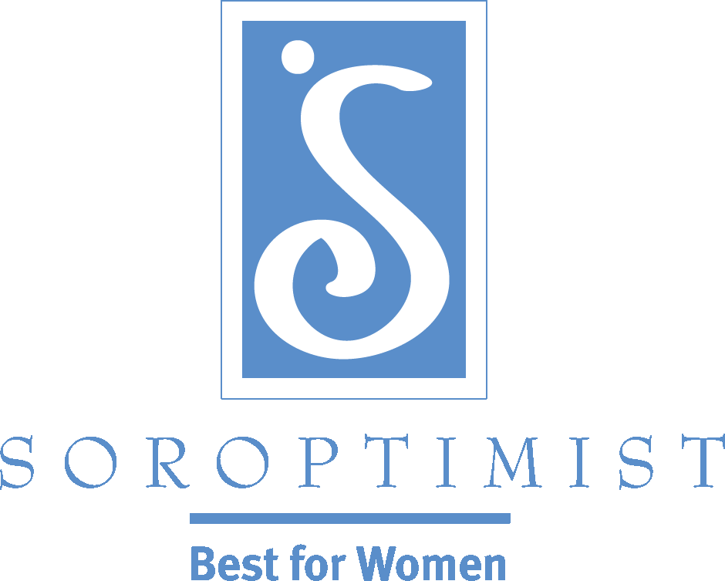
Improving the lives of women and girls
through programs leading to social
and economic empowerment.

Soroptimist International of the Americas
Recruitment Tip: Conduct a simple but meaningful one-day project
A short, one-day project can serve as an opportunity to establish connections, build relationships and provide volunteer opportunities for women in your community—including prospective members!
While continuing your ongoing recruitment efforts, why not consider recruiting volunteers first? If you invite some women to volunteer for a short, one-day project—without soliciting them for membership right away—you could build a relationship with them. Perhaps joining as a member would be a natural transition at some point. It would also give your current members some time to get to know the new prospects and become comfortable in a non-threatening environment with their work-styles and ideas. Working with other prospects also increases the comfort level of potential members who will probably be much more likely to join after a successful project or two!
A simple but meaningful community project can help generate good publicity with the potential to attract the women that you would like to have as members. For example:
- Assemble and donate tote bags containing pajamas, undergarments and various personal hygiene items to support homeless women to help women feel more comfortable during their difficult transitions.
- Partner with your local school to provide kits containing instructional materials for girls on topics such as bullying, self esteem, teen dating violence or internet safety.
- Partner with a local hospital or women’s health clinic to provide kits for women who are undergoing chemotherapy and/or who have had a mastectomy.
Check out some other ideas in the Soroptimist One-Day Club Projects resource in the program section of the SIA website!

