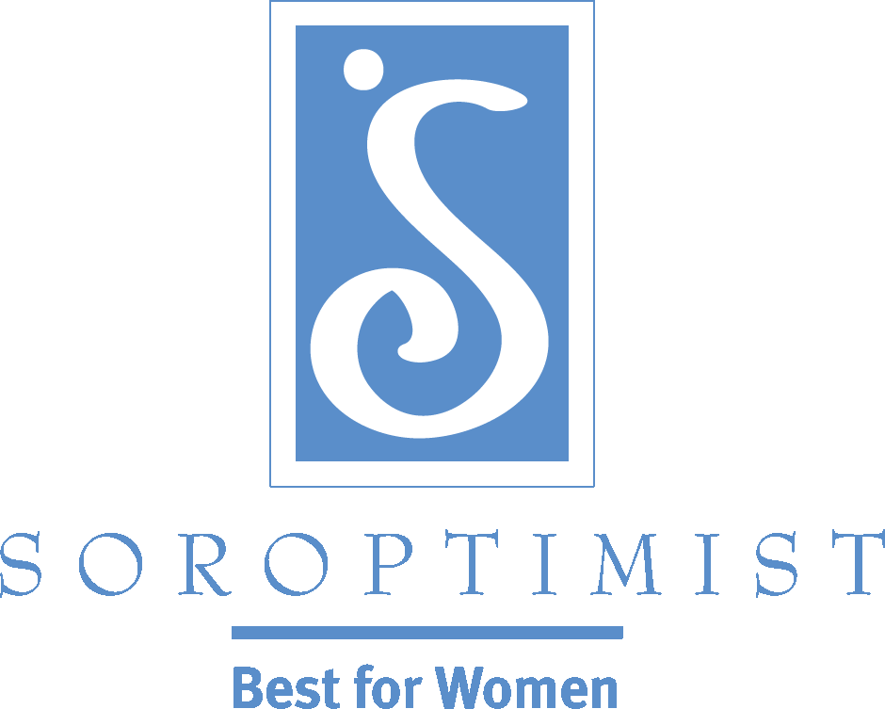
Improving the lives of women and girls
through programs leading to social
and economic empowerment.

Soroptimist International of the Americas

Bylaw Changes FAQ

The seven proposals of the 2014 Laws and Resolutions mail ballot were all passed with the required two-thirds approval by voting clubs. The details of the counted votes can be viewed in the Teller's Report.

The Board of Directors elected to steward the organization appreciates the time members and clubs gave to carefully considering the background materials provided to assist our clubs in making informed decisions, and helping Soroptimist to Shape Our Future.

The approved bylaws mean the membership changes are in effect now. The approved graduated dues increase will be effective with the 2015-2016 club year.

As with any change, there may be underlying reservations and concerns. This “Frequently Asked Questions” document has been prepared to provide further clarification about the bylaw changes. Additional questions or concerns should be addressed to: siahq@soroptimist.org.

Membership Criteria

What bylaws changes were made to membership criteria?
The membership criteria changes are:
- Membership in clubs is no longer based on occupations and classifications. Each club shall maintain a membership of individuals from the community who support SIA’s mission.
- Regular, Retired/Unemployed, and Embarking members will now all be known as “Regular” members.
- The definition of Regular member is a dues-paying individual who supports SIA’s vision, mission, and core values.

Why was occupational status removed?
At the time Soroptimist was formed, there was a need to base the organization around business and professional women and classifications were an important value as women broke new ground in the workplace. This no longer holds true in present day. To be of service in helping women and girls improve their lives, the employment status of a woman is no longer relevant.

Why are classification codes no longer needed?
Classifications codes are based on careers and professions. Without the stipulation on an individual's occupation for membership, these codes are no longer necessary.

What if our club wishes to continue only inviting professional and business women to club membership?
This practice will limit the available group of people to help the clubs help women and girls in their communities. However, clubs are free to approach membership in the way that makes most sense for them. That means, if a club continues to prefer to invite members, they may do so.

Why are the three member types (Regular, Retired/Unemployed, and Embarking) now all referred to as "Regular" members?
Regular, Retired/Unemployed, and Embarking members can all contribute to their club’s profile, projects, and programs. Without membership based on occupations, referring to all of these members as simply “Regular” more accurately defines who they are and also helps break down barriers that have excluded women who may wish to join and help SIA deliver its mission. A woman at any stage of her life is a valued prospective or retained member if they are interested in the organization’s vision, mission, and core values and wish to participate in a club.

I was a Retired/Unemployed or Embarking member type—what do I need to do change my type to Regular?
Members do not need initiate any changes to their member type. Your SIA headquarters team has been directed by the membership to reflect this change in our member database just by you voting yes to the Members Type bylaw change. They will be making more modifications to membership reports to reflect the member type changes. All rights and benefits for the regular member remain the same.

Are there any changes to Life members?
No, these bylaws changes do not affect Life members. As a reminder, Life members are those members who achieved life member status by July 2001 and who have maintained that status. A life member designation is no longer offered by the federation.

Who can be a member of SIA?
Membership is available to individuals who support SIA's vision, mission, and core values:
- VISION—Women and girls have the resources and opportunities to reach their full potential and live their dreams.
- MISSION—Soroptimist improves the lives of women and girls through programs leading to social and economic empowerment.
- CORE VALUES—Soroptimist International of the Americas is committed to:
  - Gender Equality: Women and girls live free from discrimination.
  - Empowerment: Women and girls are free to act in their own best interest.
  - Education: Women and girls deserve to lead full and productive lives through access to education.
  - Diversity & Fellowship: Women from varied backgrounds and perspectives work together to improve the lives of women and girls.

How do we update our club bylaws so they are in line with SIA's?
According to SIA Parliamentarian Connie Deford, Professional Registered Parliamentarian, “Clubs can make editorial changes in their bylaws (to conform to the SIA bylaws) instead of going through the bylaw amendment process. The subsidiary unit bylaws cannot be in conflict with the parent organization.” Therefore, clubs can go ahead and make the editorial changes to the membership sections in their bylaws to conform to SIA’s bylaws. Any other sections of their club bylaws that are purely the club’s practice that the club may wish to amend must be amended through the regular process of notice, discussion, and a vote.

When will membership resources and forms be updated?
Most membership resources and forms have already been updated in English and posted online. Other document translations are in process and will be posted as soon as they are available. Note, Form 5008: New Member Enrollment/Reinstatement and Form 5010: Membership Information Change, Transfer or Termination are already available in English, Portuguese and Spanish.

Are the SIA Procedure changes related to membership made in November 2013 still in effect?
Yes, the changes to the SIA Procedures made in November 2013 by the SIA Board of Directors to the "Procedures Governing Clubs" are still in effect:
- Clubs should maintain 12 or more regular members.
- No club shall forfeit its charter due to having 11 or fewer regular members unless they are not in good standing.
- To be a club in good standing, a club must remain current in all financial obligations to the region and Federation and have submitted all required final reports from Federation club grants and disaster relief grants.
- To charter a new club, a minimum of 12 regular members are necessary.

Federation Dues Increase

What will be the cost of federation dues?
The 2015-2016 club year federation dues will be $68 USD per regular member. This will provide an individual's membership for July 1, 2015-June 30, 2016.

What are the future increases in federation dues?
The 2016-2017 club year federation dues will be $70 USD and 2017-2018 club year federation dues will be $72 USD. Beginning in 2018-2019, and every year following, the Board of Directors shall establish the annual dues, based on the previous year’s dues rate and the anticipated cost of living adjustment (COLA) projections. By March 31 of each year, the Board may elect to maintain the previous year’s rate if conditions do not warrant an increase or it may round up or down to the nearest dollar as appropriate if an increase is determined to be necessary.

How will the Board of Directors determine COLA?
In the U.S., where the federation is incorporated, COLA (Cost of Living Adjustment) is widely used to benchmark the cost of doing business; COLA fluctuates regionally and nationally. The Board will decide on the tools they will use to assess the necessity of cost of living adjustments to the dues prior to using them for decisions to increase or maintain dues beginning in 2018-2019.

Why did we need a federation dues increases?
A dues increase was necessary because member dues were not in line with the true cost of membership. Currently, it costs about $70 for the federation to serve each member. Federation dues at $52 per member created an unsustainable funding gap. The dues increase will enable SIA to prepare for another century of making social change. The Soroptimist mission has never been more relevant, and with a renewed effort to stabilize club membership and pursue other means of involving people in our mission, the organization sees good days ahead—both for members and for the women and girls served through Soroptimist programs.

Why do we need a federation headquarters to provide service to clubs?
Soroptimist was established as a federated model over 85 years ago with all levels of the organization in various countries working together to achieve the mission. The central organization, or SIA, sets the overall vision as established by the Board of Directors, acts a spokesperson for the cause, and provides for a professional centralized staff (headquarters) dedicated to creating an environment in which clubs can operate legally and efficiently to deliver the mission. The regions ensure the clubs’ initiatives are in alignment with the vision, and the clubs carry out the initiatives in service to the mission.

In 1988 when the current governance structure was debated, the members and the volunteer leadership requested, as part of the governance change, for there to be more professional support from headquarters. The membership no longer wanted to administer the organization; they wanted to focus on advancing the mission of our organization through service, not administration. Since then, the SIA Board of Directors has assigned headquarters the responsibility for carrying out the Board’s strategic direction in addition to administering to all levels of our federation.

By being a Soroptimist, members are part of the federated model, where professional staff provide services to regions, clubs and members of Soroptimist, and now execute the Board-agreed-upon strategic plan to Shape our Future.

How are my federation membership dues spent?
Federation membership dues pay for member services:
- Member Support
- Volunteer Development and Recognition
- Governance
- Corporate Structure
- Marketing/Website
- Convention
- SI Coalition Support

How will this federation dues increase benefit my club and me as a member?
The Soroptimist organization will be able to continue providing the member benefits, products and services clubs and members have come to expect and deserve to carry out programs under the Soroptimist name. In addition to enabling clubs to accomplish the mission of improving the lives of women and girls, these benefits, products and services also contribute to a meaningful club experience. They include:
- Translation and interpretation in all federation languages (English, Japanese, Chinese, Korean, Spanish and Portuguese)
- Recruitment and retention assistance and materials
- Club support and advice
- Program resources and toolkits
- Federation programs (e.g. Live Your Dream Award)
- Global marketing and public relations efforts
- Publications including Best for Women newsletter (in all languages)
- Full access to the federation website
- Biennial convention
- Operating under the Soroptimist International name
- Maintenance of the technology infrastructure
- Upholding the governance structure (clubs, regions and the federation)
- Safeguarding financial, legal and cultural aspects necessary for operating a global business
- Generation of non-dues revenue
- Research and development of programs that address women and girl issues
- Leadership development throughout the organization.

How can we prepare for the 2015-2016 increase?
Club leaders can begin having conversations with members so they are aware of the increase and can plan their personal finances accordingly. Clubs may wish to consider options such as allowing members to pre-pay dues in increments. SIA will communicate with club presidents, treasurers, and region leadership in March 2015 with budgeting reminders and suggestions for the 2015-2016 club year. The annual dues billing will then be sent to clubs in May 2015.

What do we do about fluctuating exchange rates driving up the cost of our dues?
While it is difficult to eliminate exposure to unanticipated changes in the exchange rate between two countries, there are ways to mitigate currency fluctuation or exchange rate risk. The regions outside of the U.S. may want to consider foreign exchange hedging strategies to protect against exchange rate risk. Foreign exchange derivatives such as forward contracts, futures contracts, options, and swaps may be available through your investment banks. SIA acts accordingly by anticipating its SI dues payment and purchasing forward contracts to manage the exchange rate risk before the payment is due.

