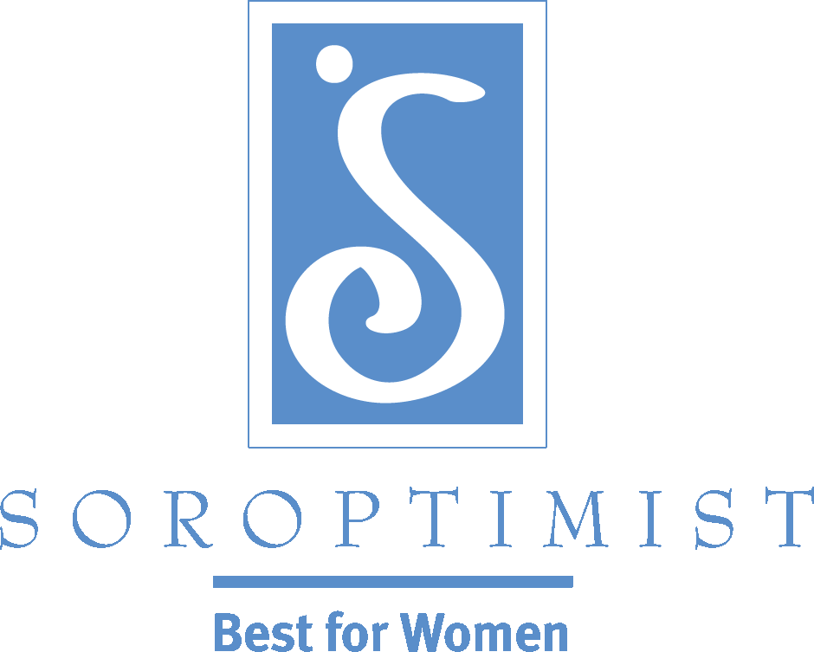
Improving the lives of women and girls
through programs leading to social
and economic empowerment.

Soroptimist International of the Americas
Recruitment Tip: The Elevator Speech
The idea of an “elevator speech” is to have a short (30 seconds or less), prepared presentation that grabs attention and says a lot in a few words. An elevator speech comes in handy when you attend an event, a conference, a convention, or some other type of meeting with networking opportunities. By telling your core message, you will be marketing yourself and Soroptimist in a way that will make people want to know more about you and our amazing organization.
What are you going to be saying in this brief oration? Convey excitement about Soroptimist in order to spark the interest of potential members. Highlight your projects—what is unique about your club? Talk about the fun events you hold. When delivering your elevator speech—believe it, deliver it with energy and enthusiasm, smile and leave them wanting more! See some samples below:
Soroptimist
Soroptimist is an organization of women who use their collective power to provide other women and girls with the resources and opportunities they need to reach their full potential and live their dreams. Our unique focus on women and girls provides the opportunity to make a better world for ourselves, our daughters and the generations of women to come. Collectively, Soroptimist has helped more than 30,000 women reach their goals and live their dreams through our Live Your Dream: Education and Training Awards for Women, by providing access to education and skills-training. Our club‘s “Professional Clothing Closet” project, which provides gently used clothing to women who need office attire for job interviews, is just one of the ways we are directly affecting the lives of the women in our local community.

LiveYourDream.org
LiveYourDream.org is an online volunteer network providing programs to help women and girls. You choose your cause and course of action based on how much time you have. We give you the tools online to take action offline in your own community. It’s free and there is no commitment required. You can do what you want, when you want; whether it’s hosting your own awareness campaign or working one-on-one with a woman in need, you choose your own adventure! This initiative is sponsored by Soroptimist, an international women’s organization that works to improve the lives of women and girls all over the
world.
Continually perfecting and updating your elevator speech ensures that you are always able to put your best foot forward. Be sure to keep it fresh and make changes as necessary based on your specific audience!
Consider holding a contest for members to craft a brief “elevator speech” to prepare everyone for extending the gift of membership! This also provides an opportunity for members to really think about why they joined and why they stay.

